
Practical Report
For IoT Practical

Darshan Ramjiyani (DSP)
DOCS, KSKV Kachchh University

- 5.7 – Simple Analog and Digital Input

- Arduino Code:

const int potPin = 0;
int ledPin = 13;
void setup()
{
pinMode(ledPin, OUTPUT);
Serial.begin(9600);
}
void loop()
{
int val;
int percent;
val = analogRead(potPin);
percent = map(val,0,1023,0,100);
digitalWrite(ledPin, HIGH);
delay(percent);
digitalWrite(ledPin, LOW);
delay(100 - percent);
Serial.println(percent);
}

- Output / Circuit Diagram:
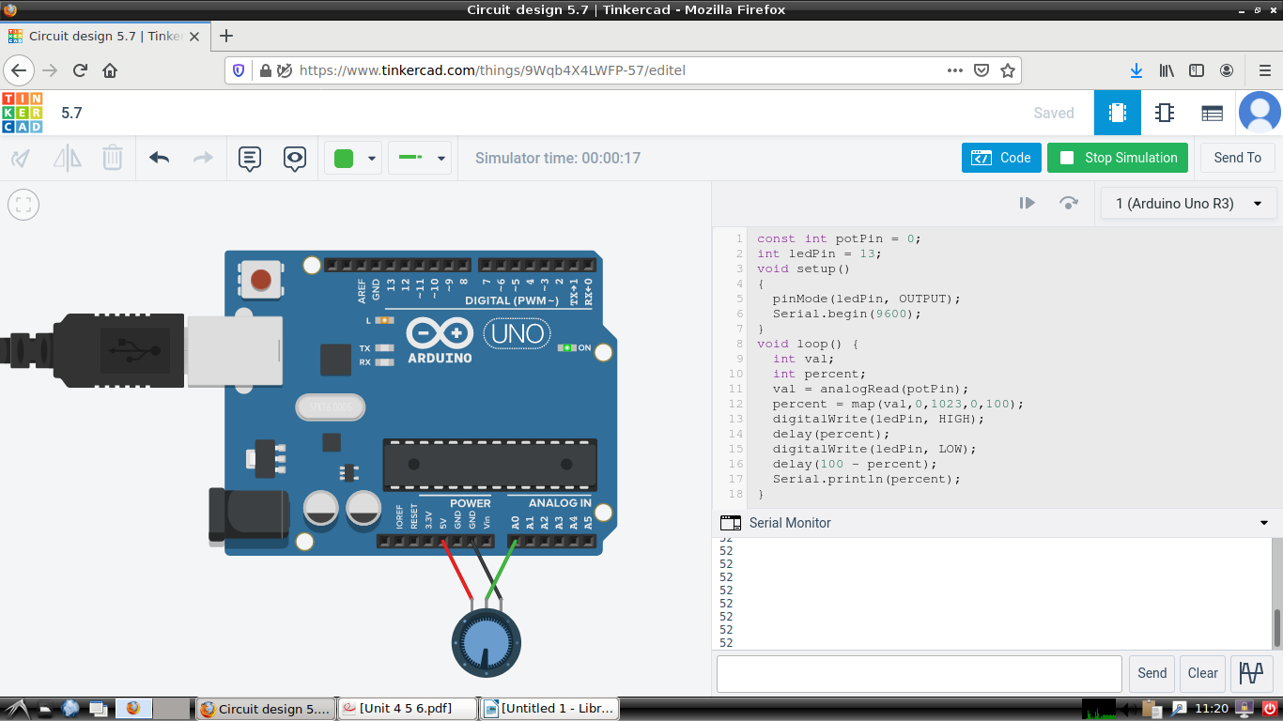
Darshan Ramjiyani

